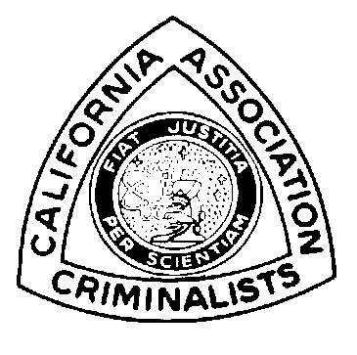

Seminar

Philip M. Kellett

Program

Donald T. Jones

Workshops

Caroline Kim

Registration

Caroline Kim
Hazel Whitworth

Vendors

John Johnson

Site

Norm Wallis

Advertisement
& Raffle

Stephanie Burton

San Bernardino
Sheriff’s Department
200 S. Lena Road
San Bernardino, CA
92415-0056

(909) 387-2200
(909) 387-2688 fax
Fall 1999 Seminar Workshops

Power Point Full day, hands-on course taught by Colleen Baker, a POST Master Instructor of Instructor Development Skills for the San Bernardino Sheriff’s Department, Training Division

Beginning Power Point – 4 hours
Basic Layouts, Backgrounds, Slide Transitions, Slide Views Fonts, Colors, and Slide Design
Intermediate Power Point – 4 hours
Custom Animation, Slide Color Schemes, Hyperlinks, Modifying Pictures, and Backgrounds

Microscopy of Botanical Traces Full day, hands-on microscopy course taught by Dr. John Shane, a specialist with McCrone Institute in the areas of palynology, botanical traces, and food microscopy.

Lecture, slides, and laboratory exercises covering the plant body and organs, cell wall, epidermis, primary and secondary tissues, wood, and anatomy of roots and seeds.

Advanced Bloodstain Pattern Interpretation Two day, hands-on course taught by Craig Ogino, Criminalist II for the San Bernardino Sheriff’s Department with teaching experience at the California Criminalistics Institute, the University of California at Riverside, and the San Bernardino County Sheriff’s Department Training Academy.

Lecture and practical exercise focusing on the photographic documentation of blood stain patterns in a mock crime scene. Proper notation with diagrams and proper lighting will be discussed. Students will provide their own cameras (with macro capabilities); film will be developed and the resulting photographs will be critiqued on the second day.

Clandestine Laboratory Documentation for Court Two day, hands-on course taught by San Bernardino County Deputy District Attorney Gar Jensen; by San Bernardino County Sheriff’s Narcotics Investigator and Clandestine Laboratory Safety Training Instructor Deputy Keith Proctor; and by Kerri Heward, Criminalist II and Kal Mistry, Criminalist I for the San Bernardino Sheriff’s Department Crime Lab.

Lecture and practical exercise with emphasis on preparation for court presentation beginning at the clandestine lab site. Topics will include manufacturing methods, safety assessment, photography, sampling, child endangerment, enhancements, and HazMat destruction. Mock lab set-ups will provide an opportunity to practice documentation. Students will provide their own cameras; film will be developed and the resulting photographs will be critiqued on the second day.

DNA Users Group Meeting Full day, lecture and information exchange

Topics to be discussed will include: Current casework experiences; methodology development; California Grant Consortium update on the implementation of the STR technology for laboratory casework and offender profiling; future technologies; court experiences.

